### Metasploit

### Subtask 1

Create a reverse shell using netcat using two Kali Linux machines. You should submit the following.

1. 1. A screenshot showing your victim receiving commands from the attacker via a netcat reverse shell.

Attacker IP: 192.168.1.112

Victim IP: 192.168.1.113

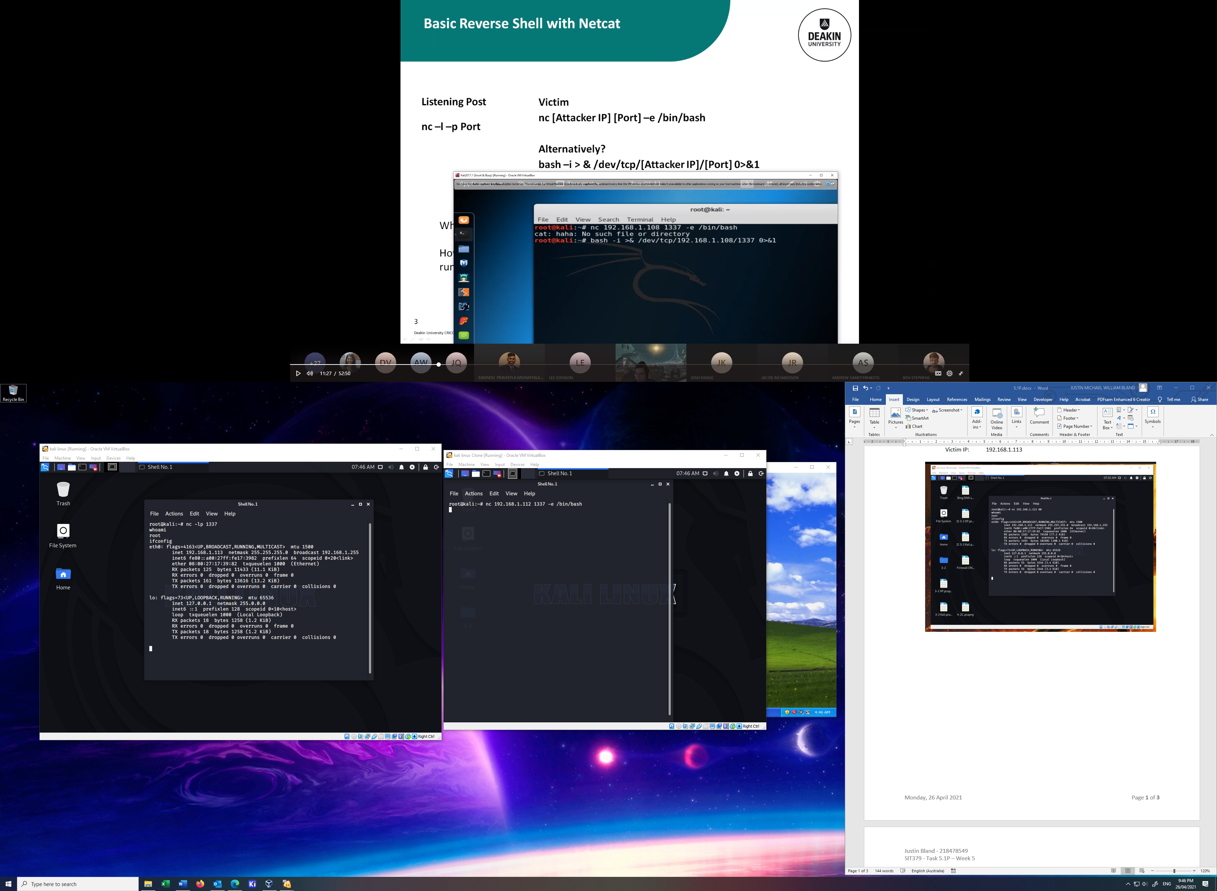



### Subtask 2

Use msfvenom to create a meterpreter exploit targeting XP. Create a listening post on Kali and then run the exploit on the XP machine. You should submit the following.

1. A screenshot showing your victim receiving commands from the attacker via a metasploit reverse shell.

Attacker IP: 192.168.1.112

Victim IP: 192.168.1.109

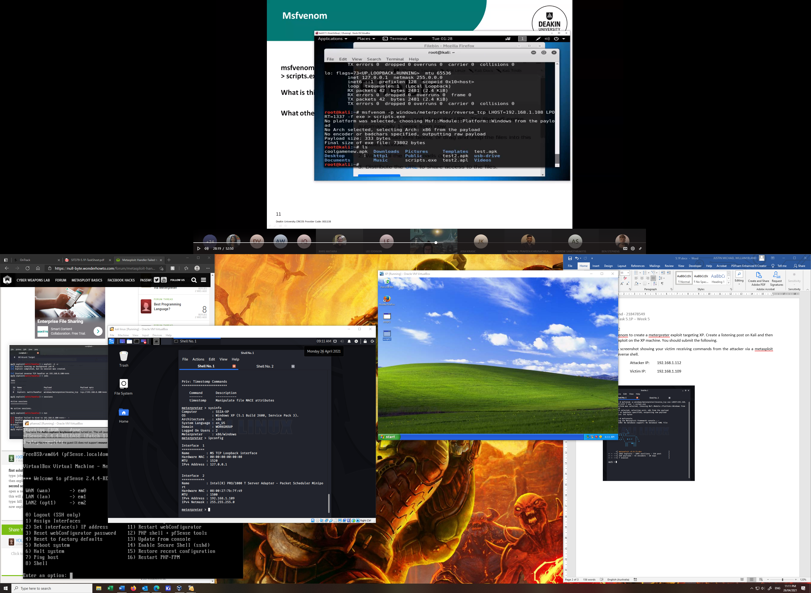

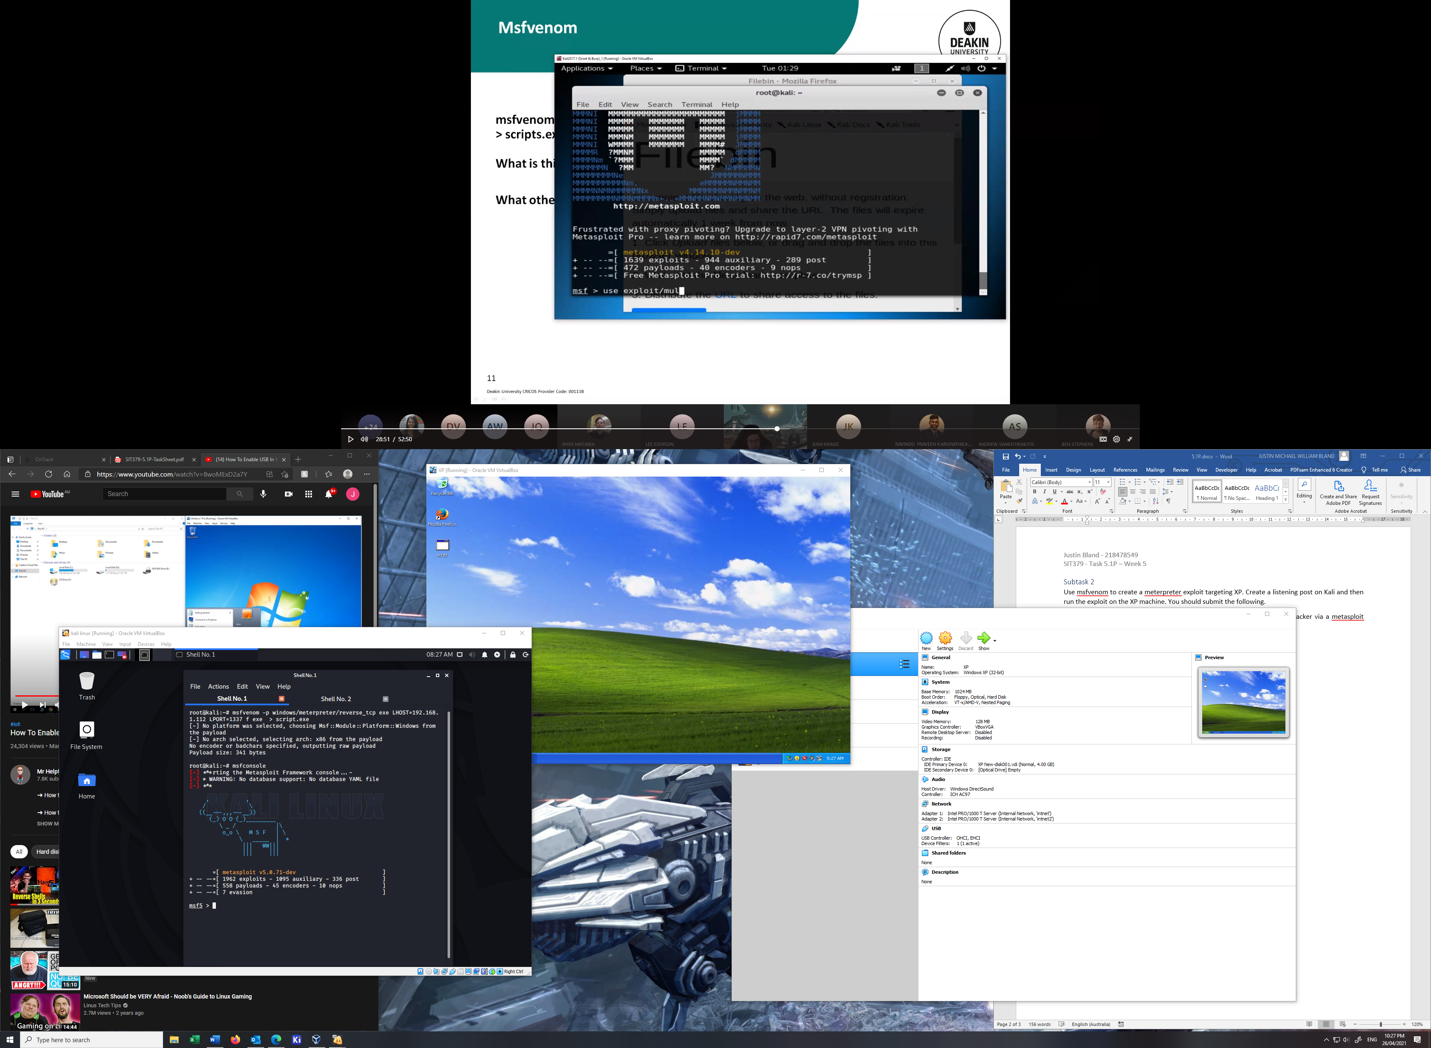

### Subtask 3

Use metasploit to attack windows XP using exploit ms08_067_netapi . Create a listening post on Kali and then run the exploit on the XP machine. You should submit the following.

1. A screenshot showing your victim receiving commands from the attacker via a metasploit reverse shell, as well as a screenshot configuring ms08_067_netapi.

Attacker IP: 192.168.1.112

Victim IP: 192.168.1.109

